Erasmus+ Programme
Capacity Building in Higher Education


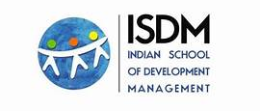









Teaching for Impact: A Teacher’s Training Manual
(01 Jan '24 to 31 Dec '26)

Co-designing Learning for Impact-Focused Entrepreneurship (Co-LIFE)
June 2024
hello@colifeproject.eu
Colifeproject.eu
Document Information
Project acronym | Co-LIFE
Project name | Co-designing Learning for Impact-Focused Entrepreneurship
Project code | 101127266 — Co-LIFE — ERASMUS-EDU-2023-CBHE
Document name | Teaching for Impact: A Teacher’s Training Manual
Document title | Teachers Training Manual
Versions | Version 1.0
Version 1.0 | Deliverable D6.1
Deliverable description | The teacher’s manual is essentially a report summarising the various training programmes and workshops that have been conducted.
Date of Delivery | 31/08/25
Work Package | WP6
Lead Beneficiary | Goa Institute of Management
Type | Document, report (R)
Dissemination on Level | Public — PU

The European Commission's support for the production of this publication does not constitute an endorsement of the contents, which reflect the views only of the authors, and the Commission cannot be held responsible for any use which may be made of the information contained therein.

Co-LIFE Project
The state of the environment and the economy require altering the way we approach business transactions (cf. the UN Sustainable Development Goals). Innovative sustainable interventions addressing social inequality and environmental degradation are required to create employment opportunities for sustainable growth. The Co-LIFE project aims to produce innovative educational measures in impact-focused entrepreneurship (IFE) in four (4) Indian HEIs. Project partner institutions in Europe and India have come together to co-develop educational content (course curriculum), learning materials, and novel innovative pedagogics to advance IFE-based education in India. This educational collaboration between Indian and EU-based HEIs (including students as co-developers) involves creating a tight stakeholder ecosystem in India and between India and the EU. The proposal involves local companies, non-academic organizations, and relevant stakeholders bringing innovative added value for social inclusion. This will produce positive social, economic, and environmental results through knowledge-sharing. Through close collaboration between HEIs, companies, and associations, e. g. via impact-focused entrepreneurship activities, the Co-LIFE project will create change in communities, in the short and long term. India needs sustainable interventions to exploit their demographics and vibrant ecosystem for entrepreneurial growth. The goal is Erasmus+ CBHE goals. Additionally, enhancing intercultural relations between the EU and India among HEIs, students, teaching staff, and local businesses and associations is an objective. HEIs and the ecosystem created in the project will benefit from exchanging best practices in learning and teaching methods and practical ideas towards employment and sustainable development in their respective areas.




Introduction and Overview


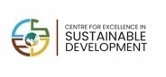
The teacher’s training manual is designed to support educators in adopting innovative teaching methods. The manual provides step-by-step guidance, tools, and templates for practical application. The teacher’s manual was developed as a core deliverable (D12) for the Co-LIFE project funded under the Erasmus+ CBHE program of the European Commission.
Under this deliverable of the Teachers Training work package, the objectives are twofold. The first objective is to develop a training programme led by experts in the fields of social and sustainable entrepreneurship, and also pedagogical innovations. This included the following key activities:
- Conducting an international roundtable discussion on key aspects of impact-driven entrepreneurship.
- Facilitating experience sharing by practitioners engaged in impact- focused entrepreneurship.
- Organizing online workshops on pedagogical techniques for delivering courses on Impact-Focused Entrepreneurship (IFE).
The second objective was the creation of a community of trainers, which includes:
- Creation of a cross-country platform for participants who had undergone the training programme.
- Online platform to facilitate interactions between the trainers.
Through the International Faculty Development Program (IFDP), we have aimed to successfully implement and demonstrate the impact of this deliverable. This Teacher's Training Manual serves as a comprehensive report summarising the various training programmes conducted under this initiative.

Co-LIFE Project Brief
The state of the environment and the economy requires altering the way we approach business transactions (cf. the UN Sustainable Development Goals). Innovative, sustainable interventions addressing social inequality and environmental degradation are required to create employment
The Co-LIFE project aims to produce innovative educational measures in impact-focused entrepreneurship (IFE) in four (4) Indian HEIs.
Project partner institutions across Europe and India have come together to co-develop educational content (course curriculum), learning materials, and novel innovative pedagogics to advance IFEbased education in India. This educational collaboration between Indian and EU-based HEIs (including students as co-developers) involves creating a tight stakeholder ecosystem in India and between India and the EU. The project involves local companies, non-academic organizations, and relevant stakeholders bringing innovative added value for social inclusion.
This will produce positive social, economic, and environmental results through knowledge sharing. Through close collaboration between HEIs, companies, and associations, e. g. via impact-focused entrepreneurship activities, the Co-LIFE project will create change in communities, in the short and long term. India needs sustainable interventions to address and exploit their demographics, entrepreneurial growth, and vibrant ecosystem.
The goals are in line with the Erasmus+ CBHE goals. Additionally, enhancing intercultural relations between the EU and India among HEIs, students, teaching staff, and local businesses and associations is an objective. HEIs and the ecosystem created in the project will benefit from exchanging best practices in learning and teaching methods and practical ideas towards employment and sustainable development in their respective areas.

Project Partners
The Co-LIFE project is a collaborative initiative led by a consortium of eight higher education institutions from Europe and India. The project focuses on designing and developing impact-oriented educational content in general management and entrepreneurship for Indian universities. It brings together European and Indian perspectives, enabling the sharing of expertise, combining knowledge bases, and exchanging best practices across the two continents.
The aim is to integrate successful approaches that influence business, sustainability, development, entrepreneurship, social innovation, and education-related strategies and technologies used in both India and the EU. A key feature of the project is its use of human and technological resources from both regions to develop academic content that empowers local communities with the skills and tools needed to generate employment.
The participating institutions from Europe include LAB University of Applied Sciences, Finland (the lead partner), LAUREA University of Applied Sciences, Finland, Thomas More in Belgium, and Aarhus University - Department of Business Development and Technology, Denmark. From India, the partners are the Goa Institute of Management in Goa, the Arch School of Design and Business in Jaipur, the Ecole Intuit Lab (EIL) in Mumbai, and the Indian School of Development Management in Delhi.

The project is organized into several work packages designed to support its main objectives. These focus particularly on the application of innovative teaching and learning methods tailored to the needs of Indian higher education institutions. All partner institutions contribute to each work package to ensure active participation and collaborative development throughout the project.
One of the key outcomes of the project is the Teacher Training Manual, developed under Work
Package 6 (WP6). This manual is the result of insights gathered from an ongoing eight-month International Faculty Development Program (IFDP), organized for faculty members from HEIs across India and Europe.
1.3 International Faculty Development Program
The International Faculty Development Program (IFDP) focuses on empowering faculty members to foster impact-driven entrepreneurship within their institutions, helping them inspire and guide students to create meaningful, sustainable ventures that contribute to positive social and environmental change. It is an eight-month program, running from January to October 2025.
The program consists of four modules, all of which are available online on the MOOC platform. The first module was an International Roundtable Discussion in January 2025. The second module was an online workshop in April 2025, focusing on experiential learning pedagogy and a novel pedagogy of learning through development for Impact Focused Entrepreneurship. The third module, in May 2025, covered the case study method of teaching and also included an online training session on activitybased teaching with a focus on Impact Focused Entrepreneurship. The final module, on service design and design thinking, will take place in October 2025.
A brochure outlining the program's timeline and key highlights was circulated widely via email to educational institutions across Goa and to project partner institutions internationally. This outreach resulted in 51 registrations, including 42 participants from India and 9 international participants.
Participants were then onboarded onto the MOOC (Massive Open Online Course) platform, which was created to upload relevant resources, initiate discussions, and share recordings of each module.
The Faculty Development Program (FDP) on impact-focused entrepreneurship is designed to equip educators with valuable insights, practical teaching methodologies, and essential tools for course delivery.
This program is designed for educators teaching at the graduate and postgraduate (Master’s) levels, offered at no cost, and provides educators with the opportunity to learn new pedagogical approaches from international experts. The program also offers a digital platform for teachers to engage in discussions with fellow professors in the field.
Structure and Overview

Figure
2
Module description
:

Module 1
•
International Roundtable Discussion
Module 2
•
Experiential Learning
•
LBD (Learning by Developing)
Module 3
•
Teaching with Cases
•
Activity Based Pedagogy
Module 4
•
Design Thinking
•
Service Design
Timeline
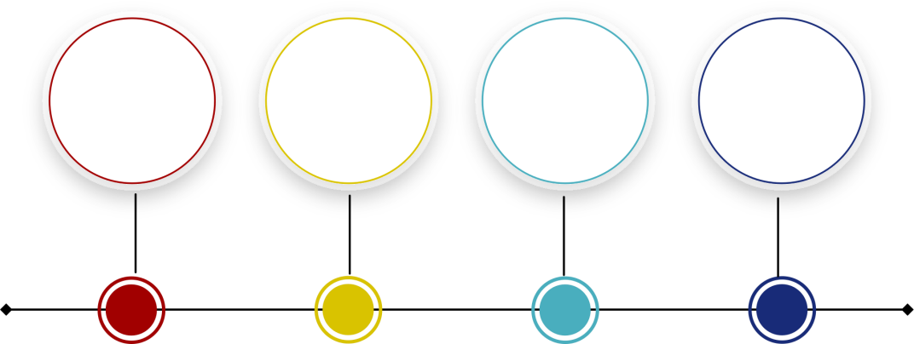

May

Module
2

Module
3

Module
4

Module 1

April

January

October

International Roundtable Discussion

2.1 Report
Delivery led by: Goa Institute of Management
An International Roundtable Discussion on “Impact Focused Entrepreneurship: Fuelling the Transition to a Sustainable Future” was held on 29th January 2025 at the Goa Institute of Management campus. The twohour session brought together around 70 participants, including faculty from colleges in Goa, FPM students, GIM faculty and staff, and Co-LIFE participants. The discussion aimed to explore how entrepreneurship can act as a catalyst in addressing pressing global challenges such as climate change, inequality, the circular economy, and resource scarcity. During the session, speakers shared their perspectives on the evolving landscape of impactdriven entrepreneurship, examining its challenges and opportunities within the Indian and European contexts. They also reflected on the role of education, policy, and collaboration in nurturing a robust ecosystem for sustainable, purpose-led ventures. This session was moderated by Prof. Neeraj Amarnani, a faculty member at the Goa Institute of Management.

2.2 Discussion summary
The following section presents a discussion summary, capturing key points and perspectives shared during the session.
The International Roundtable Discussion, part of the Co-LIFE Project, launched an 8-month International Faculty Development Programme (FDP) for Higher Education Institutions (HEIs). Esteemed speakers included Dr. Søren Tranberg Hansen, Deputy Head of Mission Science and Innovation Consul at Innovation Center Denmark, Bangalore; Nitin Kunkolienker, Chairman, Advisory Council and Mentor at MAIT, Delhi; Ravi Sreedharan, Founder and Director of ISDM; Wilma Rodrigues, Founder & Chief Transformation Officer of Saahas Zero Waste; and Pasi Rantanen, Advisor & Mentor in Innovation and Business Strategy at Ikigaia.
Dr. Hansen highlighted the importance of India-Denmark collaboration in science, innovation, and sustainability. He discussed the Green Strategic Partnership, which facilitates academic and industrial partnerships, student exchanges, and sustainability-driven entrepreneurship, while also noting bureaucratic and trade challenges. Mr. Sreedharan highlighted the struggles of social enterprises, such as poor management, lack of scalability, and financial instability. He introduced development management as a framework to support sustainable growth in the social sector, calling for leadership training and financial literacy to help organizations scale.
Mr. Kunkolienker addressed the shift from linear to exponential growth, warning that businesses failing to adapt to technological advancements risk obsolescence. He stressed that while India’s economy is growing, technological progress must be inclusive to prevent widening inequalities. Ms. Rodrigues discussed the transition to a circular economy, where recycling and resource recovery replace the traditional produce-use-dispose model. Despite existing waste management regulations, she pointed out a lack of accountability from industries and consumers. Her company, Saahas Zero
Waste, processes 100 tons of waste daily and employs 400 individuals, but scaling such operations remains challenging due to financial and regulatory barriers. Education’s role in sustainability was another key theme. While younger generations are more conscious of social and environmental issues, institutions still prioritize profit over impact. Mr. Rantanen emphasized integrating sustainability and ethics into higher education, fostering an entrepreneurial mindset that balances profit with social responsibility.
Panellists stressed the need to build local capabilities to reduce dependence on global supply chains. Regulatory challenges were also discussed. While policies ensure fairness and accountability, excessive regulations can hinder innovation and sustainability initiatives. Panellists advocated for more flexible, innovation-friendly policies and greater collaboration between industry, academia, and government. The discussion concluded with a call for impact-driven entrepreneurship, urging stronger policies that support innovation while ensuring social equity and sustainable growth. This roundtable discussion helped the participating teachers understand the complexities of developing and operating an impact-focused entrepreneurship in India.

Experiential Learning and Learning by Development

3.1 Report
The Module 2 workshop on Experiential Learning and Learning by Developing was held on 8th April 2025, with 29 participants in attendance and a total duration of 3.5 hours. The module was divided into two parts. The first part was a 1.5-hour session conducted by LAUREA University of Applied Sciences, focused on Learning by Developing, and the second part was a 2-hour session facilitated by the Indian School of Development Management (ISDM), focused on Experiential Learning as a pedagogy.

3.2 Learning by Developing (LbD) Pedagogics
(Module 2 Part 1)
Delivery led by: LAUREA University of Applied Sciences
Introduction: Learning by Developing (LbD) is a pedagogical model created at LAUREA University of Applied Sciences in the early 2000s (LbD Guide 2024).
The core of the model is built around authentic workplace projects, generally originating in the university’s own research and development projects or organizational and business partnerships (see: What is Laurea’s Learning by Developing model? Video 2024).
In contrast to more traditional approaches to teaching and learning – there is little room for memorization and standardized testing in the LbD model. Teachers’ role is to act as coaches and guide and support student teams’ learning through giving them space for creating solutions (LbD Guide 2024) to the challenges proposed by working life partners.
Their task is to present subject specific theory, as well as information on practical innovation tools in a course which exploits the LbD pedagogical model. LbD ensures that both students and teachers are jointly engaged in a multidisciplinary cooperation and learning experience (see e. g. Ojasalo and Kauppinen 2023).
LbD is rooted in Problem-Based Learning (PBL), which uses minimal guided instructions and was originally applied e. g. in legal and medical studies at the tertiary level (see Welsh, Warelow & Jackson 2009). Students are active actors in the LbD model, which highlights the importance of successful teamwork and the use of creative thinking and collaborative problem-solving skills (see Lintilä & Zarb 2022).
Networks can be created during studies, which ideally helps locating employment after the completion of studies. LbD uses continuous assessment methods, peer reviews, and self-reflective practices – as such evaluation practices help in providing a comprehensive view of course learning outcomes and students’ development
LbD projects offer university working life partners the opportunity to collaborate with tertiary-level educational establishments on a short- as well as long-term basis (LbD Guide 2024). During such project assignments, students regularly bring new perspectives and ideas to solving companies’ challenges.
The partner organisations are involved in the evaluation process of student presentations, offering constructive criticism and suggestions for improvement (ibid.). In LbD course collaboration activities, partner organisations are also gaining know-how about the skills that are needed by future employees. Such joint work can result in creating new job opportunities and finding suitable candidates for positions in the company / organisation (ibid.).
Learning by Developing (LbD) and Impact-Focused Entrepreneurship (IFE)
Impact-focused entrepreneurship (IFE) is characterized by ventures that aim to achieve positive social, environmental, and economic impacts (see Mukerji 2025). Unlike traditional entrepreneurship, which prioritizes financial returns, sustainable business and impact-focused entrepreneurs are driven by the desire to contribute towards solving societal challenges such as inequality, poverty and climate change, while creating profitable business concepts and solutions (see also Myyryläinen & Pajari 2021; Williams, Nason, Wolfe & Short 2023).
The LbD model aligns with IFE by encouraging students to engage in authentic commissions from projects that address real-world challenges and contribute positively to society. As projects in the context of Universities of Applied Sciences (UAS) in Finland gain funding through competitive Calls for Projects, they inherently involve social sustainability and environmental impact issues (see e. g. CeMeWe Project; Vuorela & Lehtosaari 2024). For example, students work on developing socially sustainable products or services that reduce environmental impact while fostering economic growth (ibid.). This hands-on approach not only enhances entrepreneurial skills but also - at best - instills a sense of responsibility and ethical consideration in future business practices (see LbD Guide 2024).
Other Opportunities and Challenges in LbD-Implementations
Learning by Developing pedagogics have benefits over traditional teaching and learning methods – as LbD prepares students for the complexities of modern working life and encourages them to become proactive, socially responsible professionals (LbD Guide 2024). However, implementing the LbD model involves also other opportunities, as well as some challenges.
Opportunities for Developing Teamwork and Organisational Skills
It is important that students as LbD team members maintain positive interdependence and that they are encouraged to rely on each other to achieve common team goals and divide tasks based on team members’ strengths (see also O’Neill, Boyce & McLarnon 2020). Hence, creating a Team Contract at the beginning of the process is essential, where agreement is sought e. g. about the required level of quality of the work. For this end, student teams also need to define roles to members at the beginning of the LbD process and regular debriefing sessions are to be held by student team internal ‘project managers. Each student is responsible for their own contribution to the team. Regular progress reports to project commissioners and instructors, as well as peer evaluations help maintain accountability (LbD Guide 2024). Thus, student teams need to jointly reflect on their performance to help identify areas for improvement.
Students should proactively seek to engage in improving social skills such as open communication and conflict resolution to promote efficient LbD-based teamwork. Direct interaction among team members is encouraged to build trust and improve collaboration; conflicts are inevitable in any team setting and resolving them effectively is crucial for maintaining a positive and productive environment (Chaudhary & Arora 2023).

Challenges in Acknowledging Differences in Students’ Levels of Expertise and Motivation
Teams often consist of members with multidisciplinary backgrounds and of varying levels of skills. Balancing such differences in expertise to ensure every one’s contribution can be challenging both for instructors and student team leaders (‘project managers’). Another challenge is assessing students' performance in a way that accurately reflects their individual learning and development. This requires building both individual and group assignments into the LbD-based course curriculum (see LbD Guide 2024 for more information).
Aligning schedules among students, lecturers, and industry partners can be difficult. This is especially challenging when team members demonstrate differences in commitment. Some students will be less motivated or engaged, affecting the overall team dynamics and project outcomes (see O’Neill, Boyce & McLarnon 2020). Also, coordinating team-internal meetings can be problematic. Clearly scheduled meetings with agendas and collaborative workshop sessions ensure that students have opportunities to build working relationships under the leadership of a student selected for ‘project manager’.
Effective communication is crucial for teamwork, but differences in communication styles and expectations can create misunderstandings (Sanmas, Quadir, Nahria & Laili 2024). The need for continuous guidance and feedback from instructors requires substantial time and resources, which needs to be acknowledged at the institutional level.
While teams in the LbD approach can face several of the above-mentioned challenges, foreseeing this and proactively implementing effective processes and tools to overcome such hindrances will help mitigate the issues and foster a productive learning environment. By addressing coordination, communication, skill diversity, motivation and conflict resolution at the outset of the LbD teamwork, teams are aware of the risks and can cater for them as and if they arise in order to achieve successful project outcomes.

Conclusion
In conclusion, the Learning by Developing (LbD) model developed at Laurea University of Applied Sciences offers a dynamic and practical approach to education, emphasizing real-world project assignments and multidisciplinary collaboration. By integrating LbD into instructing Impact-focused entrepreneurship (IFE) not only enhances students' entrepreneurial skills but also instills a sense of social responsibility, while improving teamwork skills. Despite challenges such as balancing diverse expertise and maintaining motivation, the model's focus on teamwork, continuous assessment, and proactive problem-solving prepares students for the complexities of modern working life, fostering both personal and professional growth.

References

CeMeWe Project. Central Baltic Mentoring for Migrant Women Seeking Employment. Accessed 26.6.2025.https://www.laurea.fi/en/projects/c/central-baltic-mentoring-for-migrant-womenseeking-employment/

Chaudhary, S. & Nitin A. 2023. Turning Conflict into Collaboration: The Power of Constructive Conflict Management for Your Team. Journal of Population Therapeutics and Clinical Pharmacology, vol. 30, no. 15, Jan., DOI: 10.47750/jptcp.2023.30.15.006

Crawford, R. & Jenkins, L. E. 2019. Making Pedagogy Tangible: Developing skills and knowledge using a team teaching and blended learning approach. Australian Journal of Teacher Education, 43(1). Retrieved from http://ro.ecu.edu.au/ajte/vol43/iss1/8
LbD Guide. 2024. Accessed 26.6.2025. LbD in English - Laurealainen pedagogiikka LbD – Pedagogical model in Laurea - Laurea LibGuides at Laurea University of Applied Sciences
Lintila, T. & Zarb, M. 2022. Piloting the Learning by Development Action Model Pedagogy in UK HEIs. Conference proceedings: IEEE Frontiers in Education Conference (FIE). Available at https://urn.fi/URN:NBN:fi-fe202301306587
Mukerji, M. 2025. Measuring Impact. Unpublished lecture material. January 2025. Co-LIFE Project.
About Us – Co Life Project
Ojasalo, K., & Kauppinen, T. 2023. Learning by Developing: A Guide to Practical Implementation. Laurea University of Applied Sciences.
O’Neill, T., Boyce, M. & McLarnon, M. J. W. 2020. Team Health and Project Quality Are Improved When Peer Evaluation Scores Affect Grades on Team Projects. Frontiers in Education, vol. 5, May, DOI: 10.3389/feduc.2020.00049.
Myyryläinen, H. & Pajari, A. 2021. Perspectives to Social Impact. Social enterprises benefit from communicating the social value they produce. In Sallinen, N. & Juvonen, P. (eds) LAB Innovations Annual Review. Lahti: The Publication Series of LAB University of Applied Sciences, part 28 ISSN 26701928 (PDF) ISBN 978-951-827-377-9 (PDF), 38-47.
Sanmas, M., Quadir, A., Nahria, N. & Laili, I. 2024. The Role of Interpersonal Communication in Enhancing Teamwork Effectiveness in the Digital Era. LITERATUS, vol. 5, no. 2, Mar. 2024, DOI:
10.37010/lit.v5i2.1503
Vuorela, T. & Lehtosaari, T. 2024. Kicking off Co-LIFE Project: Co-designing Learning for ImpactFocused Entrepreneurship (IFE) in India. Blog. Laurea UAS: Laurea Journal.
URN http://urn.fi/URN:NBN:fi-fe2024090969810
Wells, S., Warelow, P. & Jackson, K. 2009. Problem Based Learning (PBL): A Conundrum. Contemporary Nurse, Vol. 33, No. 2, October, 191–201. DOI:10.5172/conu.2009.33.2.191.
What is Laurea's Pedagogical Model? Laurea UAS, 2024. (2:06 min). Video (2 minutes) opens in YouTube. What is Laurea's Pedagogical Model? https://www.youtube.com/watch?v=XahTgB9BwDE&t=1s
Williams, T. A., Nason, R. S., Wolfe, M. T. & Short, J. C. 2023. Seizing the Moment—Strategy, Social Entrepreneurship, and the Pursuit of Impact. Strategic Entrepreneurship Journal, Vol. 17, No. 1, Jan.,3–18, DOI:10.1002/sej.1456.
Laurea University of Applied Sciences. 2024. Learning by Developing (LbD): Laurea’s competencebased pedagogical model built around authentic workplace projects, research, and partnerships. https://libguides.laurea.fi/lbd/english
Laurea University of Applied Sciences. 2023. Learning by Developing (LbD): Laurea’s pedagogical model centred on student competence-building through authentic development tasks and collaboration with working life. Article dated 27 June 2023.https://www.laurea.fi/en/laurea/laureaas-a-university/learning-by-developing-lbd/
Laurea University of Applied Sciences. 2021. What is Laurea’s Learning by Developing model? YouTube, 20 Jan.
Kallioinen, O. 2007. The Competence-Based Curriculum at Laurea. Laurea University of Applied Sciences
(Theseus publication series B25). https://urn.fi/URN:NBN:fi:amk-2016070113473

3.3 Experiential Learning: In Theory and Practice
(Module 2 Part 2)
Delivery led by: Indian School of Development Management
What is Experiential Learning?
Experiential learning emphasizes learning through direct experience, reflection, active engagement, and meaning-making. As a pedagogical approach, it challenges the conventional model of knowledge transmission, which is often linear and positions learners as passive receivers, with little or no agency to contribute to the learning process they are part of. Instead, experiential learning acknowledges that learners are as involved in constructing their learning as the educator. The role of the educator in this approach is to create educative experiences rather than view themselves as knowledge providers.
This pedagogical shift has been shaped and supported by educationists and philosophers like John Dewey and Paulo Freire, who have offered frameworks that help educators engage with experiential learning as a body of knowledge. Dewey (1938), in Experience and Education, emphasized the importance of moving away from debating traditional forms of education vs progressive forms, and instead explored the philosophical underpinnings of experience and education. In Education for Critical Consciousness (1973), Freire urges us to recognize that learners bring their own experiences and perspectives to the learning process and are thus co-investigators in it rather than empty vessels. These theoretical foundations inform the core principles that guide effective experiential learning design, which are covered in the following section.
Core Principles of Experiential Learning
Principle 1: Learner Agency
Learners' own prior knowledge, perspectives, and experiences must find voice in the co-inhabited space they share with their educators, and learning should be seen as a co-construction process.
Principle 2: Meaning, Continuity & Interaction
Each experience must build meaningfully upon previous ones in a cumulative process and cannot be a standalone entity.
Principle 3: Reflection Turns Experience into Learning
An experience in itself may be insufficient unless followed by a deliberate reflection. A reflective process should provide space to look back at the experience in terms of what happened, what learnings emerged and what meaning was extracted.
Principle 4: Adaptability & Responsiveness
Experiences must be responsive to learners’ specific contexts and backgrounds, while being agile enough to shape themselves to how the experience unfolds in the learning space.
Principle 5: Purposeful Experience
Not all experiences are educative and lead to learning. ‘Educative’ experiences have to be designed with intentionality, clear purpose, direction, and aligned with desired learning outcomes.
Principle 6: Synthesis and Coherence
Experiential learning must aim to synthesize learner agency, continuity, reflection, agility, and purpose into a cohesive whole.
Experiential Learning in Action
Case Studies engage learners by taking them through complex, real-life dilemmas that mirror professional challenges. By being encouraged to apply theories, frameworks, and approaches, learners experience challenges - operational and ethical, for instance- in decision making and develop critical thinking.
Immersion and Field-based Learning take students into communities, the field, or organizations, and is a way for them to observe and experience complexity and ambiguity in real time. They become participants in what unfolds, which provides insights unavailable through traditional classroom methods.
Simulations, Role Plays, and Theatre are great ways of allowing learners to step into real or imagined roles through which they get to explore complex issues from different perspectives, while practicing decision-making in a controlled environment.
Design Challenges engage learners by providing them with an open-ended problem that they have to address through innovative solutions, guided by empathy, iteration, and real-world constraints.
Project-based approach involves collaborative projects addressing real needs, building knowledge through action, reflection, and social responsibility, while developing practical skills.
The strength of these approaches lies in their versatility and in their ability to be used either as standalone experiences, in combination with each other, or as an element of something larger. However, when designing any learning experience, it is essential to remember the principles of what makes a meaningful and educative learning experience. Without that alignment, the experience may generate considerable curiosity, but fail to address any specific learning needs.
To illustrate how these principles translate into practice, we will now examine the ISDM approach that has been developed in the context of their Post Graduate Programme on Development Management.
The ISDM Approach
The Indian School of Development Management (ISDM) offers an 11-month Post Graduate Programme in Development Management that responds to the unique nature of the development sector, which is value-driven, people-centered, and deeply context-specific. It has long been acknowledged that the sector is shaped by complexity, ambiguity, and constant change, often presenting wicked problems, which are complex issues with no clear definitions or solutions. These wicked problems require iterative, collaborative, and contextually grounded responses.
To prepare for such realities, it is essential to take learners beyond classroom theory. Thus, at ISDM, the pedagogy is experiential-based and the whole programme is designed in a way that provides learners adequate opportunities to engage with real-world problems through critical reflection and collaborative approaches. In this way, the learners get to experience the uncertainty and dynamism of development work, while building on their skills and mindset which are needed to navigate and lead in such complex situations.
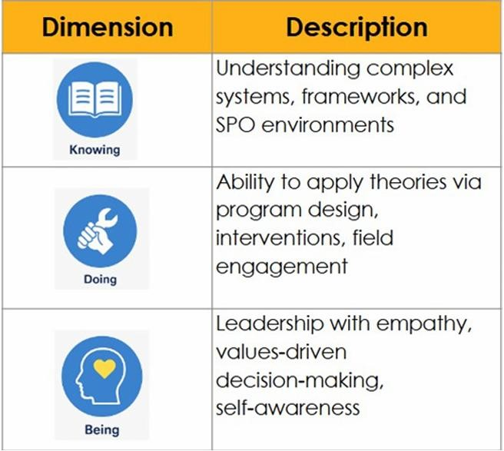
Table 1: Three Dimensions of Learning – Knowing, Doing, and Being

This experiential approach is also deeply embedded in the interconnected knowing (theories and models), doing (practical application), and being (personal values) dimension of ISDM’s educational philosophy. The learning experiences provide opportunities for learners to apply (doing) their acquired knowledge (knowing) by forcing them into positions where they have to work through ambiguity and discomfort by confronting their own assumptions and values (being). This integration strengthens their sense of purpose and nurtures the inner shifts essential for dynamic, empathetic, reflective, and responsible leadership in the development sector.
Learning Processes and Structures: A Look at ISDM’s Experiential Learning in Action
This table provides an overview of some of the processes and structures that are a deliberate part of ISDM’s curriculum to encourage experiential learning.

Process / Structure | Description
Case Studies | Part of courses; they are grounded in real development sector contexts.
Coursework | Courses such as Design Thinking & Intervention Design are focused on creating solutions to real-life wicked problems.
Real-world Dilemmas (Jury Process) | Learners have to engage with live, complex issues brought by practitioners in their jury conversations.
Realising India (Field Immersion) | A two-week field immersion across diverse geographies; designed to allow learners an opportunity to deep dive into India’s plurality and complexities.
PLCs (Professional  Learning Communities) | Consciously formed small peer groups throughout the programme; mirrors how teams work in real life and encourages collective problemsolving and collaboration techniques.
Plenaries | Structured reflection spaces that enable students to take a step back and identify emerging knowing-doing-being learnings.
Table 2: Key Learning Processes and Structures in the Programme

Common Implementation Challenges
While we have examined the ISDM curriculum and pedagogical approach briefly, which demonstrates an experiment in implementing experiential learning, there are some commonly faced challenges that educators must navigate.
- Experiential learning demands innovative strategies to evaluate reflection, personal shifts, critical thinking, practical application, alongside collaborative work.
- Resistance to adopting experiential learning may emerge due to concerns about academic rigor, time requirements, and uncertainty about outcomes.
- Learners who are more accustomed to passive methods may initially struggle with the ambiguity in the process, and responsibility that experiential learning requires from them.
- Field experiences, community partnerships, and hands-on activities require more financial and logistical support, as compared to classroom interactions.
- Institutional constraints, curriculum requirements, and accreditation standards may limit educators' ability to innovate.
- Educators may fear loss of control and the uncertainty of experiential approaches.
However, these challenges can be mitigated with intentional programme design and flexible curricula. They require patience and trust in the learner’s ability to construct knowledge, a certain level of comfort with less directive teaching styles, and adequate institutional support. Such experiences may not demonstrate shifts and transformations immediately, which makes their acceptance and practice more challenging. However, the attempt at presenting ISDM’s model is to exemplify successful implementation in professional educational settings.

Further Readings
Dewey, J. (1938). Experience and education. Macmillan Company.
Freire, P. (1973). Education for critical consciousness. Continuum International Publishing Group.
Kolb, D. A. (1984). Experiential learning: Experience as the source of learning and development. Prentice Hall.
Munich Business School. (2016). Understanding 'being': Explanation & insights from management.
MBS
Insights. https://www.munich-business-school.de/insights/en/2016/knowing-doing-being/
Pfeffer, J., & Sutton, R. I. (2000). The knowing-doing gap: How smart companies turn knowledge into action.
Harvard Business School Press.
Rittel, H. W., & Webber, M. M. (1973). Dilemmas in a general theory of planning. Policy Sciences, 4(2), 155-169.

Teaching with Cases and Activity-Based Pedagogy

4.1 Report
The Module 3 workshop on Teaching with Cases and Activity-based pedagogy was held on 12th May 2025, with 23 participants in attendance and a total duration of 2.5 hours. Like module 2, module 3 was also divided into 2 parts. The first part was a 75-minute session, focused on using case studies for teaching in the context of impact-focused entrepreneurship, and the second part was also a 75-minute session, focused on activity-based teaching methods within the same context.

4.2 Case-Based Teaching in Impact-Focused Entrepreneurship
(Module 3 - Part 1)
Delivery led by: Aarhus University - Department of Business Development and Technology
Introduction
Case-based teaching is a learner-centred instructional method that places students in the role of decision-makers facing real-world scenarios. In higher education, this approach has evolved into a powerful method for enhancing problem-solving, critical thinking, and ethical reasoning.
Its value is especially pronounced in the field of impact-focused entrepreneurship, where complex social and environmental issues intersect with innovation and business strategy. This chapter introduces educators to the principles and practices of case-based teaching, using the real-world examples of two mission-driven enterprises: Bare Necessities (India) and Too Good to Go (Denmark).
These cases highlight how values, operations, and scaling challenges can be woven into effective classroom experiences.
The Value of Case-Based Teaching
Case-based teaching connects academic theory with practice. It empowers students to:
• Think critically and solve problems by analysing real dilemmas and proposing reasoned solutions.
• Engage actively in the learning process, rather than passively absorbing information.
• Communicate effectively and collaborate with peers in group discussions and decision-making
exercises.
• Prepare for real-world impact, understanding the nuances of social entrepreneurship and
sustainable business models.
Example: Bare Necessities challenges students to think about how a zero-waste startup in India can scale without compromising on its environmental mission. Questions of growth, branding, and ethical consumerism emerge naturally from the case.
Types of Case Studies
Educators can choose from four main case types, depending on the desired learning outcome:
Type | Purpose | Example
Descriptive | Understand context and practices | Describe how Bare Necessities manages zero-waste operations.
Analytical | Interpret data and draw conclusions | Evaluate Too Good To Go's market performance across Europe.
Decision  Based | Recommend a specific course of action | Should Bare Necessities partner with a national retail chain to scale?
Problem  Based | Explore open-ended  challenges with multiple valid solutions | How can Too Good To Go adapt its model to enter Asian markets successfully?
Using different types of cases allows educators to scaffold learning across levels of complexity and cognitive demand.
Designing Effective Teaching Cases
Strong cases exhibit the following characteristics:
- Realism: Grounded in actual business scenarios and constraints.
- Relevance: Aligned with course objectives and industry trends.
- Complexity: Involve competing priorities, incomplete information, or ethical dilemmas.
- Decision points: Include a clear problem, question, or conflict.
- Evidence-based: Include data, quotes, or documentation to support student analysis.
Example Case Design: Bare Necessities
- Scenario: The company is offered a retail partnership that could double its reach but would require altering its packaging materials.
- Challenge: Can they scale ethically while maintaining credibility with their core audience?
- Options: Say no, propose a pilot with eco-certified retailers, or re-negotiate packaging standards.
Implementing Case-Based Learning
Use these facilitation techniques to get the most from a case discussion:
- Socratic Questioning: Ask open-ended prompts like "What assumption are we making here?" or "What would happen if we chose the opposite strategy?"
- Small Groups: Divide students to explore different angles and then compare perspectives in a plenary session.
- Role-Playing: Assign stakeholder roles (e.g. founder, investor, consumer) to deepen empathy and perspective-taking.
- Debriefing: End with reflective questions and links to theory. Discuss what students learned and how it connects to broader concepts.
Example Facilitation: Too Good To Go
- Use stakeholder roles (e.g. app developer, partner store, regulator, customer) to debate whether and how to enter Southeast Asia.

Common Challenges and Solutions
Challenge | Solution
Low participation | Use warm-ups, assign speaking roles, or start in pairs.
Cases feel too complex | Scaffold with summaries, visuals, or guiding questions.
Time is limited | Use short or modular cases spread across multiple sessions.

Table 4: Common Challenges in Case-Based Teaching and Practical Solutions

Applying Case-Based Learning in Impact-Focused Entrepreneurship
Use Bare Necessities and Too Good To Go as running examples to teach:
• Sustainable operations and scaling challenges
• Social impact metrics and ethical trade-offs
• Local adaptation of global models
Encourage students to:
• Map stakeholder interests
• Debate expansion strategies
• Compare different impact models
• Design their own case questions or dilemmas

Conclusion
Case-based teaching transforms students from passive learners into active problem solvers. When applied to topics like sustainable and impact-driven entrepreneurship, cases offer rich, multidisciplinary insights. By using relatable and timely examples such as Bare Necessities and Too Good To Go, educators can spark critical conversations and prepare students to lead responsibly in a complex world.
Suggested Readings
• Anderson, E. and Schiano, W.T., 2014. Teaching with Cases: A Practical Guide. Boston: Harvard
Business School Publishing.
• Ellet, William. The Case Study Handbook, Revised Edition: A Student’s Guide. Revised edition.,
Harvard Business Review Press, 2018.
• Brandenburg, Margot, and Judith Rodin. The Power of Impact Investing: Putting Markets to
Work for Profit and Global Good. Stanford Social Innovation Review, 2014.
• Mansoor, S. and Suryanarayan, V., 2024. Bare Necessities – Impact Report 2024. Bare
Necessities Zero Waste Solutions Pvt. Ltd.
• Too Good To Go, 2024. Impact Report 2024. Too Good To Go ApS.
• Poulsen, E.S., 2025. Teaching with Cases – Using Cases for Teaching. Aarhus University,
Department of Business Development and Technology.
• The Circular Catalyst, 2023. Bare Necessities – Circular Economy Award Winner. [online]
Available at: https://thecircularcatalyst.com/bare-necessities-zero-waste
• Christensen, C.M., 1997. The Innovator’s Dilemma: When New Technologies Cause Great
Firms to Fail. Boston: Harvard Business School Press.
• Kolb, D.A., 1984. Experiential Learning: Experience as the Source of Learning and
Development. Englewood Cliffs, NJ: Prentice Hall.
• Mair, J., Robinson, J. and Hockerts, K. eds., 2006. Social Entrepreneurship. Basingstoke:
Palgrave Macmillan.
• Nicholls, A., 2006. Social Entrepreneurship: New Models of Sustainable Social Change. Oxford:
Oxford University Press.
• Yin, R.K., 2018. Case Study Research and Applications: Design and Methods. 6th ed. Los
Angeles: SAGE Publications.
Additional and Support Materials:
• Practical Example – Stakeholder Summit: Scaling Sustainability. 2025. (Annex 1)
• Bare Necessities – Impact Report 2024 (Annex 2)
• Too Good To Go – Impact Report 2024 (Annex 3)
• Too Good To Go – Analytical Case Example. 2025 (Annex 4)
• Too Good To Go – Problem-Based Case Example. 2025 (Annex 5)

4.3 Activity-Based Teaching
(Module 3 - Part 2)
Delivery led by: Goa Institute of Management

Introduction
In today’s dynamic and uncertain world, learning is most impactful when it is lived, experienced, and reflected upon. Kolb’s Experiential Learning Theory offers a powerful framework for this, emphasizing that learning is a continuous process grounded in experience rather than simply the outcomes. It integrates experience, perception, cognition, and behaviour into a holistic learning process. Activity based teaching is rooted in this experiential model, where students engage actively in tasks that mirror real life challenges. Through the stages of Concrete Experience, Reflective Observation, Abstract Conceptualization, and Active Experimentation, learners are not just absorbing content but are immersed in a developmental journey of understanding and application.
This approach is particularly effective in impact focused entrepreneurship education where engagement, empathy, and experimentation are essential. In essence, activity-based teaching transforms classrooms into innovation labs, encouraging students to explore, reflect, and evolve through meaningful learning experiences.
Objectives of activity-based learning
1. To support diverse learners
2. To enhance engagement and motivation
3. To encourage collaborative working
4. To collate a very large amount of information in a particular format
5. To promote deeper understanding
6. To help understand the multi-stakeholder perspective
7. To apply theory to practice and appreciate the real-life uncertainty

Type of Activities
To enhance student engagement and deepen learning, a diverse set of interactive activities can be integrated into academic settings. Listed below are various interactive teaching activities designed to engage students and foster deeper learning, along with the key skills and outcomes they promote.

Type of Activity | Description & Learning Outcomes
Simulations | Students act out real-world business or policy scenarios using structured roles and defined outcomes. Develops decision-making, strategic thinking, and realtime problem-solving.
Role Play | Students assume specific roles such as CFOs, investors, or policymakers in guided scenarios. Builds empathy, communication skills, and understanding of stakeholder perspectives.
Debates | Structured arguments on controversial or dual-sided topics. Sharpens critical thinking, logical reasoning, and public speaking confidence.
Gamification | Incorporates game mechanics like points, levels, and badges into coursework. Increases motivation, engagement, and consistent participation.
Polls & Live Surveys | Real-time questions using tools like Slido or Mentimeter with instant feedback. Enhances participation, surfaces diverse views, and guides discussion.
Reel Making | Students create short videos (e.g., Instagram Reels) around concepts or campaigns. Fosters creativity, digital storytelling, and peer-led knowledge sharing.
Poster Making | Visual synthesis of ideas or campaigns into academic posters. Improves summarization, visual literacy, and interdisciplinary expression.
Podcast Recording | Students produce audio content like interviews or discussions. Encourages research, articulation, and deeper understanding through peer exploration.

Some Typical Situations: What Type of Activity Could Work
Choosing the right activity can depend on the learning context, goals, and classroom dynamics. Below are some mini case examples of typical situations educators may face, along with suggestions for the type of activity that could best support learning in each case. A few mini cases were used, and the participants brainstormed which activity would work best in each situation. Listed below are a few examples.
Mini Case 1
Subject: Business Ethics
Situation: Students are learning about ethical dilemmas in entrepreneurship (e.g., underpaying or overworking employees, customer privacy and data use, green washing for investors). While cases are discussed, students are hesitant to express strong views or challenge peers.
Challenge: Ethical decision-making remains theoretical; students don’t feel the emotional or moral tension real leaders face.
Suggested Activity-Based Solution: Role-Play + Live Polling: Use real-world-inspired ethical scenarios and assign roles (e.g., Entrepreneur, NGOs, employee, investors). After presenting responses, run live polls asking the rest of the class to rate decisions on fairness, legality, and leadership quality.
Why It Works: Encourages empathy, highlights complexity, and makes moral reasoning visible and discussable.

Mini Case 2
Subject: Marketing / Brand Management
Situation: Students are learning about brand identity, positioning, and storytelling. While they understand theoretical models (like Aaker’s Brand Equity), they struggle to apply them to real brands or campaigns.
Challenge: Students don’t internalize how emotional appeal and narrative structure create strong branding.
Suggested Activity-Based Solution: Podcast or Reel-Making
Assign each team a well-known or fictional brand. Ask them to create a 2-minute podcast or reel showcasing the brand story, identity, and emotional hook, using theoretical frameworks. Present to class for peer critique.
Why It Works: Bridges theory and practice, activates creative skills, and enhances communication of abstract ideas.

Mini Case 3
Subject: Entrepreneurship / Innovation
Situation: In a “New Venture Creation” course, students develop ideas but are unsure how to pitch them. Their presentations lack clarity, and many misunderstand what investors prioritize (scalability, exit, business model clarity).
Challenge: Students struggle to translate passion into persuasive, structured communication. Feedback sessions are dry and technical.
Suggested Activity-Based Solution: Role-Play + Reel-Making
Organize a “Shark Tank”-style role-play where students pitch to a panel of mock investors (faculty or peers in role). Follow up by having each group create a 90-second reel pitching their startup for social media.
Why It Works: Role-play creates real-world pressure and perspective-taking; reel-making builds concise storytelling and creative confidence.

Mini Case 4
Subject & Topic: Sustainable Finance –Climate Finance Instruments
Situation: Students are overwhelmed with sources (e.g., UN, EU Green Deal, ESG frameworks) and produce fact-heavy but unstructured outputs.
Challenge: Students struggle to extract, compare, and structure relevant information.
Suggested Activity: Chart-Making + Collaborative Infographic Design:
- Divide into teams by sub-theme (e.g., Green Bonds, Carbon Credits).
- Create visual summaries: What is it? Who uses it? Pros/cons? Global examples?
- Present and receive peer feedback.
Why It Works: Promotes visual literacy, helps synthesize information, reduces anxiety, and encourages deeper collaboration. A role play activity was conducted to demonstrate how an activity is carried out and to highlight the challenges involved.
Activity Overview
In this role-play activity, each group will collaboratively design and pitch a business idea that addresses a pressing social or environmental challenge allotted to them. Each member will take on a stakeholder role and contribute to shaping a solution that balances profitability, social impact, and stakeholder needs.
Focus Areas
Pitching for your idea, stakeholder negotiation, aligning with the societal challenge allotted to your team
Steps for participating
Each member of the team was assigned a role. Each team has been allotted a broad societal challenge.
Roles and timings
In the breakout room (10 minutes):
The team member assigned the role of an ‘Entrepreneur’ prepared and delivered a 60 second’s pitch.
Other members will raise one critical question based on the perspective of the stakeholder they are representing. The team will work together to refine the pitch by addressing each stakeholder's concerns.
In the main meeting room (2-3 minutes):
The team will present final pitch highlighting the process of incorporating the various concerns.

Challenges and some thoughts on these challenges
Table 6: Common Challenges in Implementing Activity-Based Learning and Suggested Solutions
 | Challenge | Remarks
1 | Identifying and designing an activity | Requires time, creativity and clarity of learning objectives
2 | Class Management to ensure effective implementation | Group work can lead to off-task behavior or dominance by a few students.  Difficult to monitor multiple groups simultaneously.
3 | Technological Challenges | Technical issues with online tools disrupt flow.  Not all students are equally tech-savvy or equipped.
4 | Time Management | Activities often require more time than traditional lectures.  Pressure to "cover the syllabus" can discourage use of active methods.
5 | Large class sizes | Difficult to manage interactive activities with many students.  Ensuring equal participation becomes challenging.

Tools for Facilitation
Table 7: Digital Tools to Support Activity-Based and Experiential Learning
Sr.no | Tool | Purpose | Key Features | Link
1 | Kahoot! | Quizzes & Games | Live quizzes, polls, and competitions | https://kahoot.com/
2 | Mentimeter | Real-time polling | Word clouds, Q&A, audience voting | https://www.mentimeter.com/
3 | Slido | Live Q&A, polls | Interactive sessions, integrates with PPT & Teams | https://www.slido.com/

4 | Padlet | Brainstorming | Visual, collaborative bulletin boards | https://padlet.com/
5 | Miro / Mural | Visual collaboration | Group templates, flowcharts | https://miro.com/  https://www.mural.co/
6 | Trello | Project tracking | Boards for task management | https://trello.com/
7 | Canva for Education | Creative projects | Posters, infographics, reports | https://www.canva.com/education/
8 | Google Forms | Surveys & reflections | Quizzes, polls, feedback | https://forms.google.com/
9 | Edpuzzle | Video-based activities | Embed questions in videos | https://edpuzzle.com/
10 | Harvard  Business  Publishing | Case studies | Authentic business case learning | https://hbsp.harvard.edu/
11 | Marketplace Simulations | Business simulations | Marketing/strategy simulations | https://www.marketplacesimulation.com/
12 | Cesim Simulations | Decision-making sims | Used across business fields | https://www.cesim.com/

References
Kolb, A. Y., & Kolb, D. A. (2005). Learning styles and learning spaces: Enhancing experiential learning in higher education. Academy of Management Learning & Education, 4(2), 193–212.
https://doi.org/10.5465/amle.2005.17268566
Prince, M. (2004). Does active learning work? A review of the research. Journal of Engineering
Education, 93(3), 223–231. https://doi.org/10.1002/j.2168-9830.2004.tb00809.x
Bonwell, C. C., & Eison, J. A. (1991). Active learning: Creating excitement in the classroom. ASHE-ERIC
Higher Education Report No. 1. George Washington University. ERIC Document
Fayolle, A., & Gailly, B. (2008). From craft to science: Teaching models and learning processes in entrepreneurship education. Journal of European Industrial Training, 32(7), 569–593.
https://doi.org/10.1108/03090590810899838
Neck, H. M., Greene, P. G., & Brush, C. G. (2014). Teaching entrepreneurship: A practice-based approach. Edward Elgar Publishing.
Freeman, S., et al. (2014). Active learning increases student performance in science, engineering, and mathematics. Proceedings of the National Academy of Sciences, 111(23), 8410–8415.
https://doi.org/10.1073/pnas.1319030111
Kolb, D. A., Boyatzis, R. E., & Mainemelis, C. (2001). Experiential learning theory: Previous research and new directions. In R. J. Sternberg & L. F. Zhang (Eds.),
Perspectives on cognitive, learning, and thinking styles (pp. 227–247). Lawrence Erlbaum.

Design Thinking and Service Design

5.2 Report
Delivery led by: Thomas More
The Module 4 workshop is scheduled to take place on 9th October 2025 and
will be centered around design thinking and service design.

5.2 Service Design in Impact-Focused Entrepreneurship Education

How Service Design and its approaches and methodologies can contribute to IFE education
Although there is no consensus definition of the emerging discipline, one could describe Service Design as a “(marketable) set of products and services capable of jointly fulfilling a user’s need.” (Goedkoop & Van Halen, 1999; Felix, 2011)). This also involves a new mind-set where services are created from the user perspective, in a holistic and systematic way, taking time and sequencing into consideration (Stickdorn & Schneider, 2010).
When organizing a specific service, from the service offered by a new business start-up, an organisation or a social enterprise, there are always a set of tangibles (tactile) components necessary to realize the service such as a website, a brochure, an app, a plan to provide the information, a device, a tool, an object to assist the user, a space, a room, a building to host the service. Within service design, these components are referred to as touch points and friendly, accessible, understandable touchpoints are required in order for service to be successful.
At Thomas More University of Applied Sciences, the Postgraduate Space and Service design programme adds the element of space to the definition of Service Design, expanding it to include the system of relevant services, spaces, objects, circulation and communication which jointly are able to fulfil the specific needs of the user, whether that user be the person behind the counter, the supplier, the manager or the end-user themselves.
To really understand how services distinguish themselves from one-off products, consider that services and environments are often expressed by actions of purpose. Take for example the idea how a service is offering information instead of merely providing an object like a reception desk. SSD considers both the tangible and intangible elements. SSD also differentiates between the front stage (what is visible and experienceable for the customer/user) and the backstage (what happens behind the scenes or by supporting organisations).
For students learning how to be impact-focused entrepreneurs, learning service design offers added value because it provides a structured and human-centered approach to creating solutions that are not only effective but also deeply resonate with the people they aim to help.
Why Service Design is a good fit for Impact-Focused Entrepreneurship (IFE)
For IFE, Service Design can be considered one of the core enablers of meaningful, sustainable, and scalable change. In impact-focused entrepreneurship, service design is not just a “nice to have”—it’s a core enabler of meaningful, sustainable, and scalable change. It ensures that the service is useful, usable, desirable, and aligned with your mission by:
Aligning Services with Social or Environmental Goals
Impact entrepreneurs aim to create positive change, not just profit. Service design ensures the delivery model—how the service is experienced—matches those goals. It helps translate values (e.g., sustainability, equity, accessibility) into tangible user experiences.
Focusing on User-Centeredness to Drive Real Impact
Service design puts users at the center through techniques like co-creation, journey mapping, and prototyping. For impact ventures, this is critical: if your solution doesn’t work for your intended audience, the social impact fails. Without user-centricity, good intentions often result in poor outcomes.
Including the Integration of Systems Thinking
Most impact challenges (climate, inequality, education) are complex and systemic. Service design encourages holistic thinking: mapping stakeholders, policies, environments, and workflows. This allows entrepreneurs to design interventions that work within—and influence—the broader system.
Making Innovation Practical
Impact-focused startups often innovate in resource-constrained environments. Service design helps prioritize features and optimize experiences even on tight budgets. It enables lean, iterative approaches that build better solutions faster and more affordably.
Allowing for the Measuring and Enhancing of Impact
Service design incorporates feedback loops and metrics, which are crucial for evaluating social impact. By understanding user behavior and outcomes, impact entrepreneurs can adapt and scale what truly works.
Service Design ensures that the service that is being created is useful, usable, desirable, and aligned to the goal of the organisation. By embedding SSD values into IFE entrepreneurship education, students are better equipped to design with and for communities, create services and spaces that improve well-being as well as sustainability and scalability, while grounding business ideas within the real needs of humans.
This allows IFE businesses and organisations to communicate effectively with diverse audiences and develop systemic, scalable solutions to complex societal challenges. For students, the intended outcomes include their being able to design user-centered services/spaces, communicate clearly with diverse stakeholders, prototype/test/iterate entrepreneurial concepts, apply system/holistic thinking, and create innovative solutions with measurable impact.
Challenges to implementing Service Design in the IFE classroom
Ideally, Service Design is not taught purely from a theoretical standpoint, as the methods and research tools within Service Design allow for students studying SSD to learn by doing. This can include off-site visits, fieldtrips, and flexibility in terms of student schedules. In order for Service Design to be successfully applied to live cases, the experience of the Postgraduate SSD lecturers suggests that this requires clients or organisations who are dedicated to their involvement with the students. This idea of involvement includes their ability to provide access to future or current users, as well as the availability of their own time during the coursework as well as allowing other stakeholders (such as managers, workers, etc.) in codesign workshops or interviews. Next to this, one of the most important aspects is establishing clear expectations as to what can be expected in terms of student delivery.
As with other live-case-based coursework, the access that students have to the client, their context, and their stakeholders influences the Service Design process. And limiting access directly contributes to limited authentic understanding. In this regard, integrating live cases into the curriculum requires careful management and contribution from the client which can present challenges when implemented within educational practice.
Implementing Service Design effectively, especially in resource-constrained impact-focused settings, can involve overcoming difficulties related to:
• Resource Constraints: Impact-focused startups often operate with limited resources, requiring lean and iterative approaches.
• Managing Complex Systems: Designing for complex, often "wicked" societal problems requires a holistic and system thinking approach, involving mapping stakeholders, policies, environments, and workflows. Integrating these interconnected components and addressing multi-layered societies can be challenging.
• Authentic Stakeholder and User Involvement: While essential, ensuring continuous and meaningful involvement of clients, end-users, professionals, and other stakeholders as informants, feedback providers, or co-creators throughout the design process requires significant effort, coordination, and management of diverse perspectives. Obtaining accurate, up-to-date insight information from stakeholders can also be difficult.
• Multidisciplinary Collaboration: Realising holistic spatial service systems demands multidisciplinary teamwork across different design disciplines (spatial, product, visual communication, UX) and cultural backgrounds. Coordinating and ensuring effective collaboration within such teams, alongside involving external experts, can be complex.
• Communication: Communicating research, ideas, and design outcomes in a comprehensible manner for all stakeholders, including non-designers, is crucial. Using visual tools like maps, storyboards, and personas helps but requires effort to ensure clarity and accessibility.
• Testing and Iteration: Regularly testing design proposals through pitches, mock-ups, and prototypes with users and clients to validate designs and align with requirements requires logistical planning and the ability to manage feedback effectively.
• Contextual Understanding: Thorough research of the tangible and intangible context, including desk and field research, is foundational. Gaining deep empathy and respect for the existing situation and users is vital but can be challenging to achieve comprehensively.
• Practical Constraints: Factors such as time limitations, process adherence, budget constraints, ethical compliance, accessibility requirements, and securing necessary permissions and engagement from all parties can pose practical challenges during implementation.
This said, striving to overcome these challenges ensures that students who are studying IFE have a good understanding of the context in which a business or organisation will operate. In order for students to be successful, what is most important is that understand several key Service Design principles. These include:
• Focusing on the needs, desires, and experiences of users—both tangible (spaces, products) and intangible (services, emotions).
• Collaborating with all stakeholders, from clients to professionals to logistics to end-users as co-creators and informants throughout the project.
• Addressing the full-service experience, from pre-service (how a service is discovered), the service itself (how it is experienced), and post-service (how the service is supported after the experience).
• Considering all touchpoints: spaces, communication tools, digital tools or technologies, interactions and experiences and how they work together as a unified whole.
• Understanding complex systems: visualising user flows, money flows, logistics, and behaviour patterns.
• Visualising the invisible, through the creation of prototypes of key experiences and outcomes using storyboards, visuals, and mock-ups.
• Testing ideas regularly with users and clients and iterating based on the Double Diamond approach
The Double Diamond is a visual representation of the design and innovation process. It’s a simple way to describe the
steps taken in any design and innovation project, irrespective of methods and tools used.

• Conducting in-depth qualitative research through site visits, interviews, observations, and service safaris
In conclusion
In the context of Impact-Focused Entrepreneurship (IFE), Service Design is not merely additional tools and methods to support research, but rather one of the means that of ensuring that new businesses that are created are able to deliver meaningful, sustainable, and scalable change. By adopting a Service Design approach, particularly one grounded in the principles of Space and Service Design (SSD), entrepreneurs and the students learning to become impact entrepreneurs are equipped to address complex societal challenges effectively. Ultimately, Service Design helps translate good intentions into tangible, usable, desirable, and mission-aligned solutions that generate measurable positive impact.
Suggested Service Design Resources
To further explore service design and its application in impact-focused entrepreneurship, the following resources are suggested. This includes looking at particular tools which students can use, as well as downloadable worksheets and method descriptions that are well articulated.
Videos:
• What is Service Design: A tale of two coffee shops
https://www.youtube.com/watch?v=HNOY8GLVy_8
• What is Service Design
https://www.youtube.com/watch?v=ojqN3tZqcew
• Lessons from service design with author Lou Downe
https://www.youtube.com/watch?v=b2PTGkxRwgA
Websites and Articles:
• Service Design Tools and Methods
https://servicedesigntools.org
• This is Service Design Doing
https://www.thisisservicedesigndoing.com/methods
• UK Design Council Methods for Developing Services
https://www.designcouncil.org.uk/fileadmin/uploads/dc/Documents/DesignCouncil_Design%2520methods%2520for%2520developing%2520services.pdf
References
• Design Council. (2015). The Double Diamond. https://www.designcouncil.org.uk/our-resources/the-double-diamond/
• Felix, E. (2011). Learning space service design. Journal of Learning spaces, 1(1), n1.
• Stickdorn, M., & Schneider, J. (2012). This is service design thinking: Basics, tools, cases. John Wiley & Sons.
• Van Geetsom, N. (2016). Design & Research, introduction to research for design. Herent.Acco.
• Van Geetsom, N., & Wilkinson, A. (2021, August 1). Design culture (of) resilience. Space & Service design taxonomy, overcoming undefined space & service design contexts. DESIGN CULTURE(S), Cumulus Conference Proceedings Roma 2021, Rome, Italy. Cumulus. https://cumulusroma2020.org/proceedings-files/DC(s)_PROCEEDINGS_full_vol2.pdf
• van Halen MSc, C. J., & te Riele MSc, H. R. (1999). Product Service systems, Ecological and Economic Basics.

Conclusion
Work Package 6 (WP6) is led by the Goa Institute of Management (GIM) and focuses on developing the necessary skills for the trainers to deliver a course on Impact Focused Entrepreneurship (IFE). As part of this work package, the team identified the types of training required, developed a comprehensive training module for teaching staff, and created a platform for trainers to share their experiences while delivering the program.
The training program was designed around two core aspects: interaction with experts and practitioners, and innovative teaching pedagogies. This began with an International Roundtable Discussion on Impact Focused Entrepreneurship: Fuelling the Transition to a Sustainable Future, which formed the first module of the program. The second module focused on Experiential Learning and Learning by Developing (LbD). The LbD model, developed by LAUREA University of Applied Sciences, presents a dynamic and practical approach to education. It emphasizes real-world project assignments and cross-disciplinary collaboration. Integrating this model into IFE instruction not only enhances students’ entrepreneurial competencies but also nurtures social responsibility and teamwork. In parallel, experiential learning highlights the importance of learning through direct experience, critical reflection, and active engagement to derive meaning.
Module three addressed case-based and activity-based pedagogies. Case-based teaching transforms students from passive recipients into active problem-solvers. When applied to themes such as sustainable and impact-driven entrepreneurship, case studies offer rich, multidisciplinary insights. Activity-based teaching, on the other hand, immerses students in tasks that simulate real-life challenges. Guided by the experiential learning cycle, Concrete Experience, Reflective Observation, Abstract Conceptualization, and Active Experimentation, students are engaged in a transformative learning journey that goes beyond content absorption. The upcoming fourth module will explore Design Thinking and Service Design. These approaches ensure that newly created businesses are capable of delivering meaningful, sustainable, and scalable solutions. By applying principles of Space and Service Design (SSD), entrepreneurs as well as students aspiring to become impact entrepreneurs are better equipped to tackle complex societal problems through human-centered innovation.
To support continued learning and engagement, faculty members were onboarded onto a dedicated MOOC platform, where recordings of all training sessions were uploaded, alongside additional resources and reading materials. This allows educators to revisit content, reflect on their learning, and apply insights in their teaching practice. In addition, a collaborative Co space was created within the MOOC platform, where trainers, experts, and practitioners can interact, share experiences, raise concerns, and collectively enhance their pedagogical approaches to teaching IFE. To this end, the Goa Institute of Management, in collaboration with partner institutions ISDM (Indian School of Development Management), LAUREA University of Applied Sciences, LAB University of Applied Sciences, Aarhus University - Department of Business Development and Technology, and Thomas More University of Applied Sciences, has been working through the International FDP and a faculty training manual to build awareness around the challenges and opportunities in impact-focused entrepreneurship education. The initiative has successfully conducted training sessions for faculty on innovative pedagogies and fostered the exchange of best practices for effective course delivery in both online and offline settings.

List of Figures
Figure 1: Partner Institutions……………………………....6
Figure 2: Module description.....................7
Figure 3: FDP Timeline................................7
Figure 4: International Roundtable Discussion – Featuring Speakers and Project Partners.....7
Figure 5: Live Discussion in Progress...........................9
Figure 6: Module 2: Experiential Learning and LbD Session Snapshot............ 11
Figure 7: Module 3: Teaching with Cases and Activity-Based Pedagogy Session Snapshot ...... 18
Figure 8: SSD Service safari – Design for ageing – Elderly community De Lisdodde in Mechelen. In this live case, students interacted directly with members of the residential care facility to better understand their needs, wants, frustrations, and routines……………36
Table 1: Three Dimensions of Learning – Knowing, Doing, and Being………. 20
Table 2: Key Learning Processes and Structures in the Programme………………21
Table 3: Types of Case Studies – Purpose and Examples…………………….24
Table 4: Common Challenges in Case-Based Teaching and Practical Solutions………..25
Table 5: Interactive Activity Types and Their Learning Outcomes……………………28
Table 6: Common Challenges in Implementing Activity-Based Learning and Suggested Solutions………………..31
Table 7: Digital Tools to Support Activity-Based and Experiential Learning………………..32

Appendices
Appendix A
International Faculty Development Program (FDP) Brochure
This brochure was circulated to all participants as part of the outreach and invitation process for the International Faculty Development Program. It outlines the program’s objectives, structure, session themes, dates, and speaker details. The following pages contain the full brochure as shared with the participants.

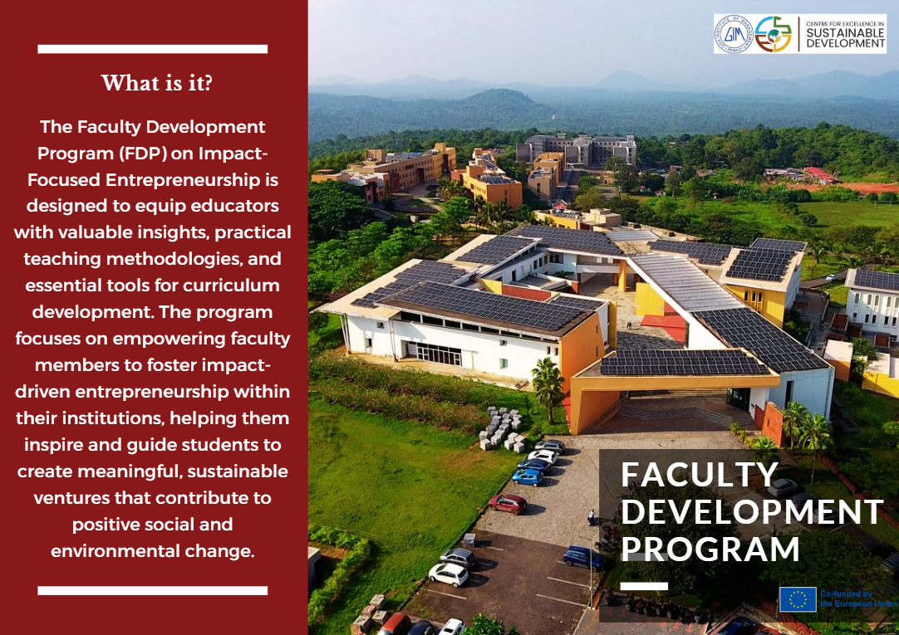

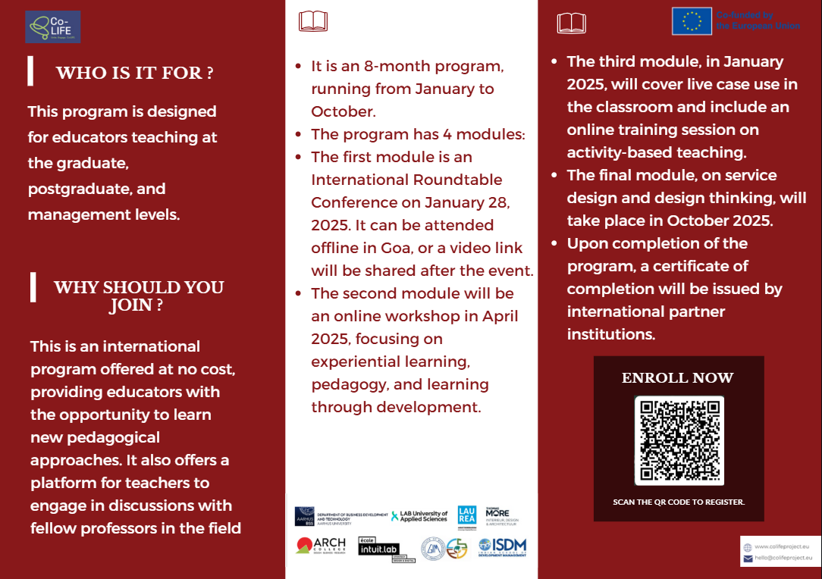

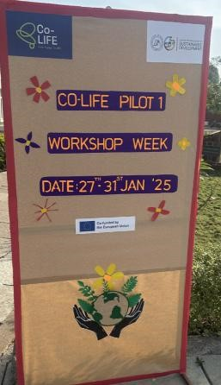
Appendix B
MOOC Course Platform Overview
The platform consists of reading materials, workshop recordings, course-related information, and a discussion forum to support educators in adopting innovative teaching methods.

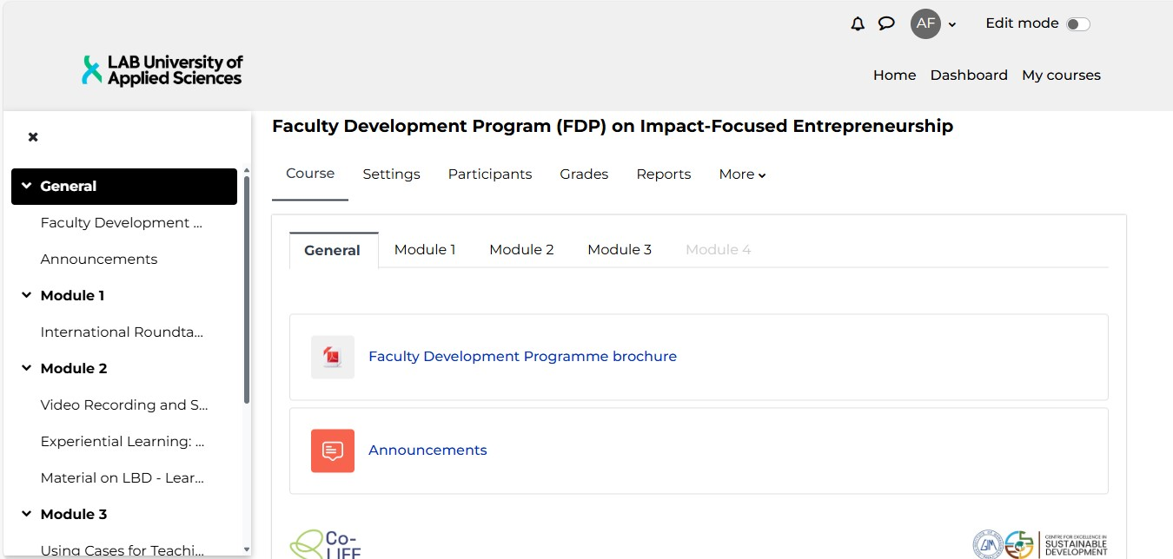

Appendix C
This appendix contains the slides on the Learning by Developing (LbD) model.
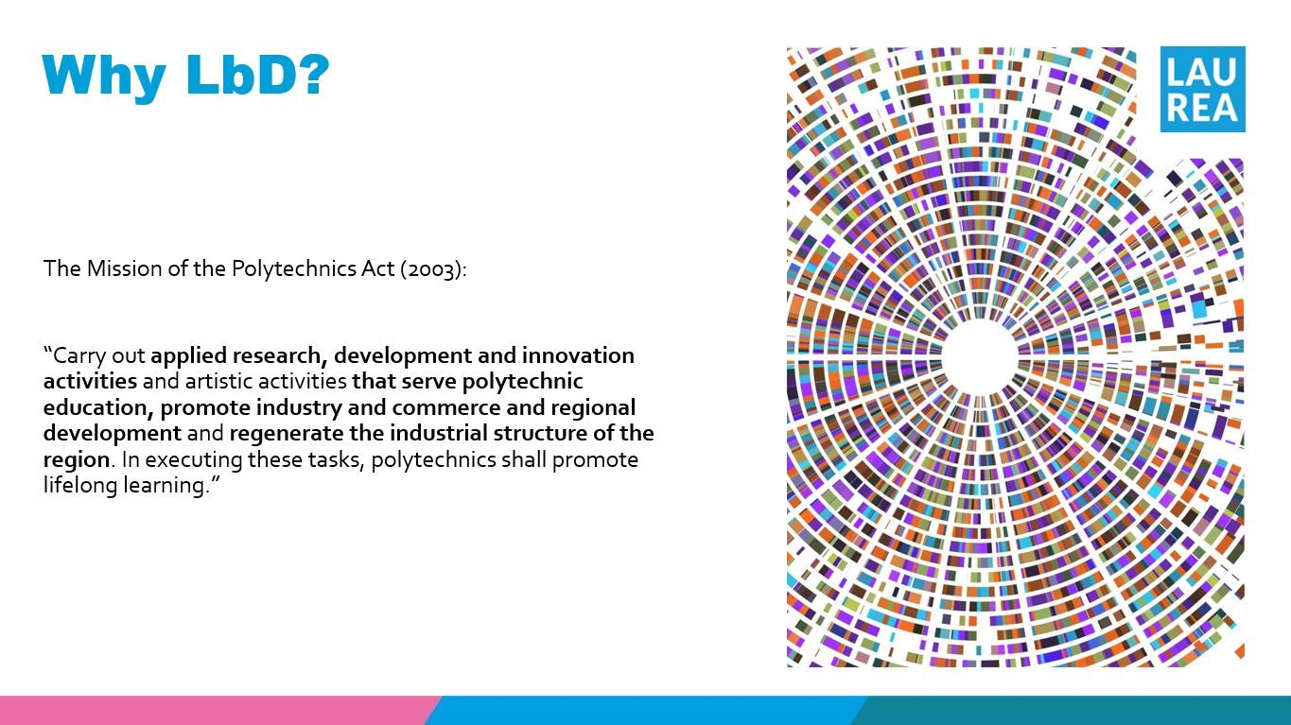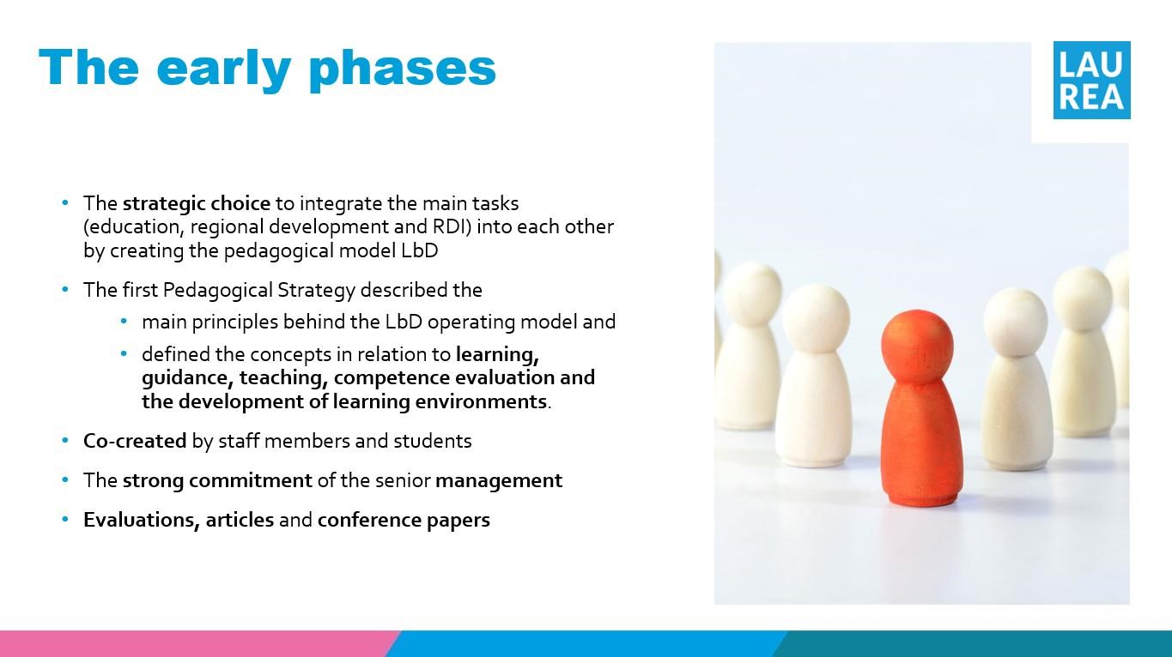

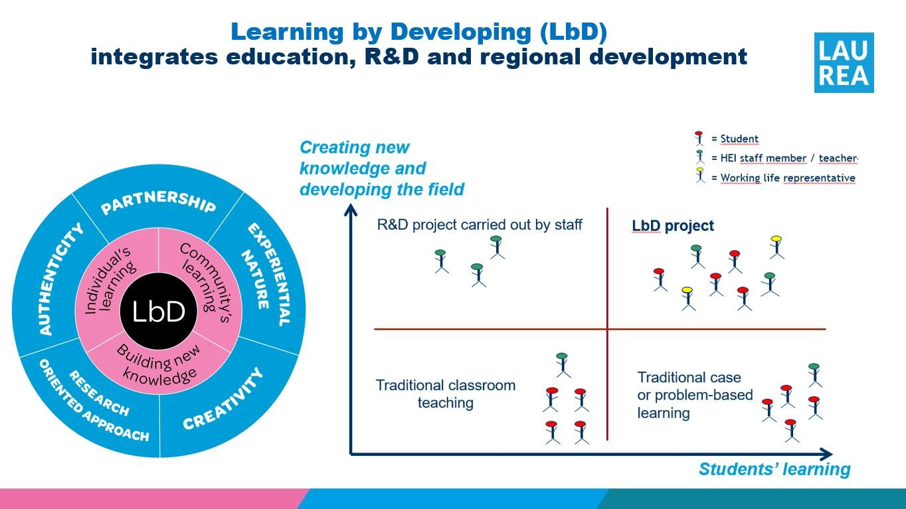

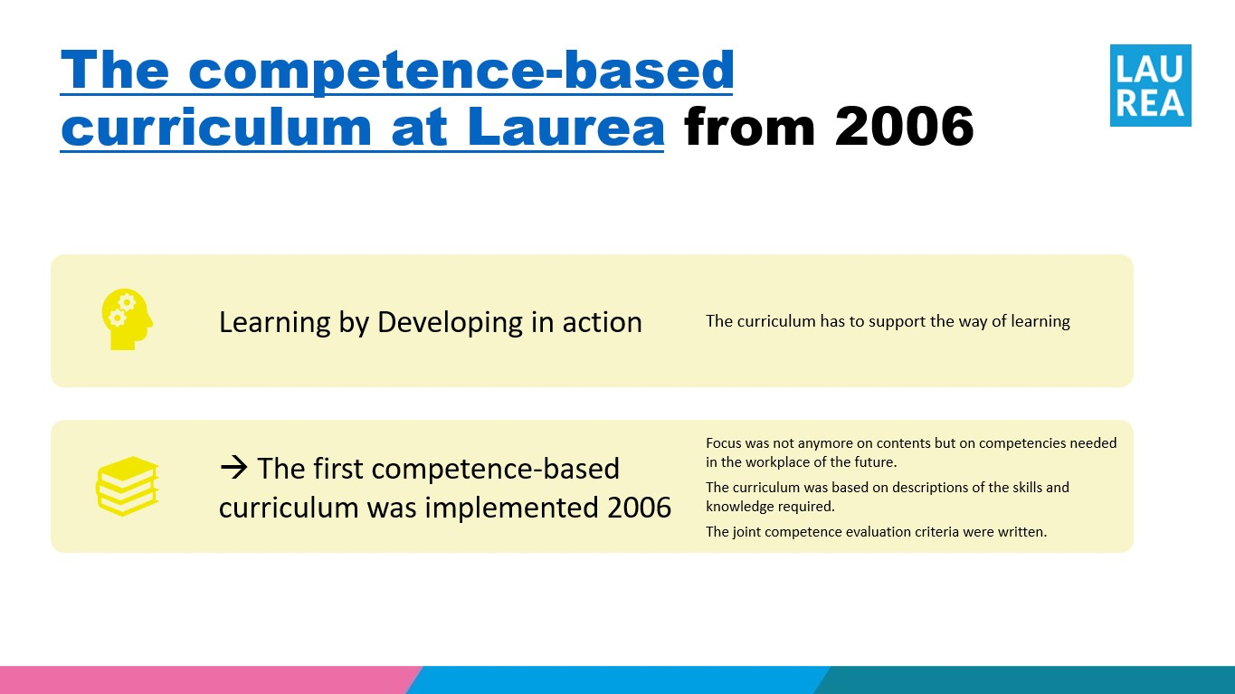

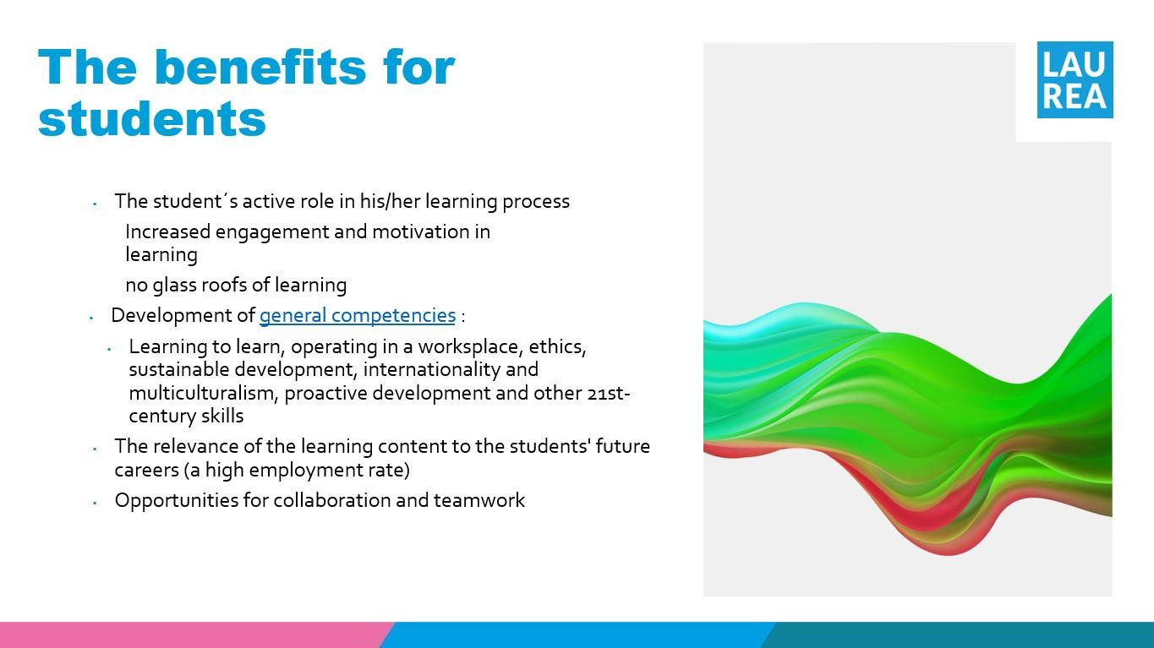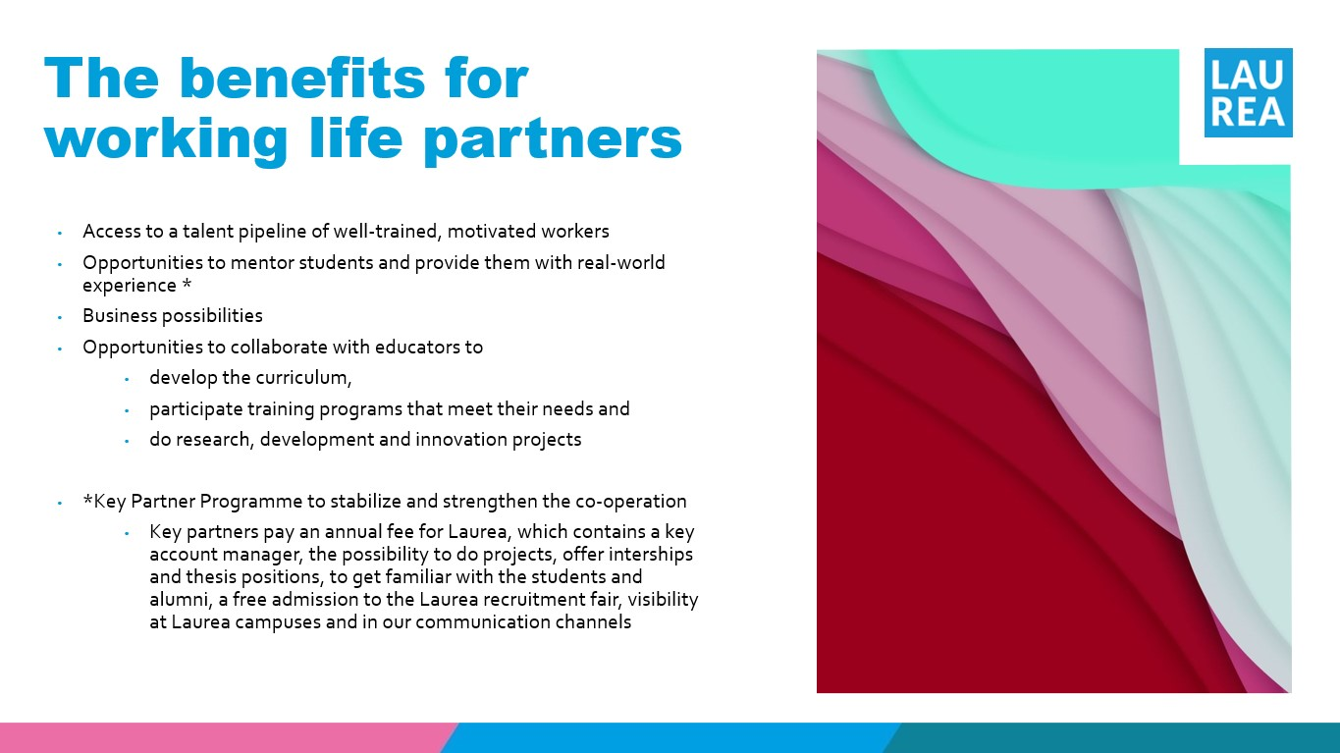

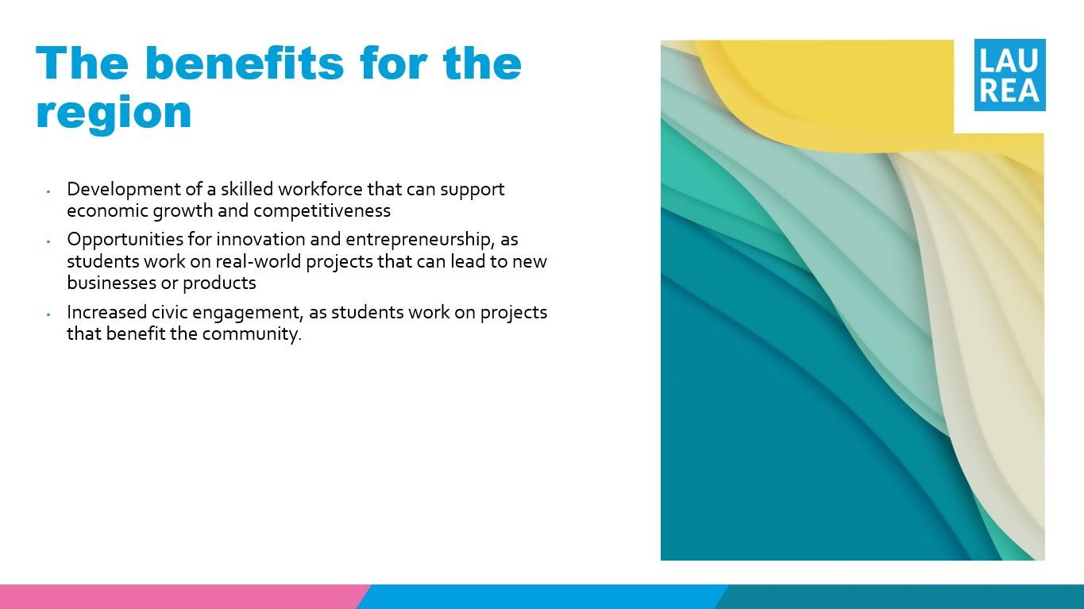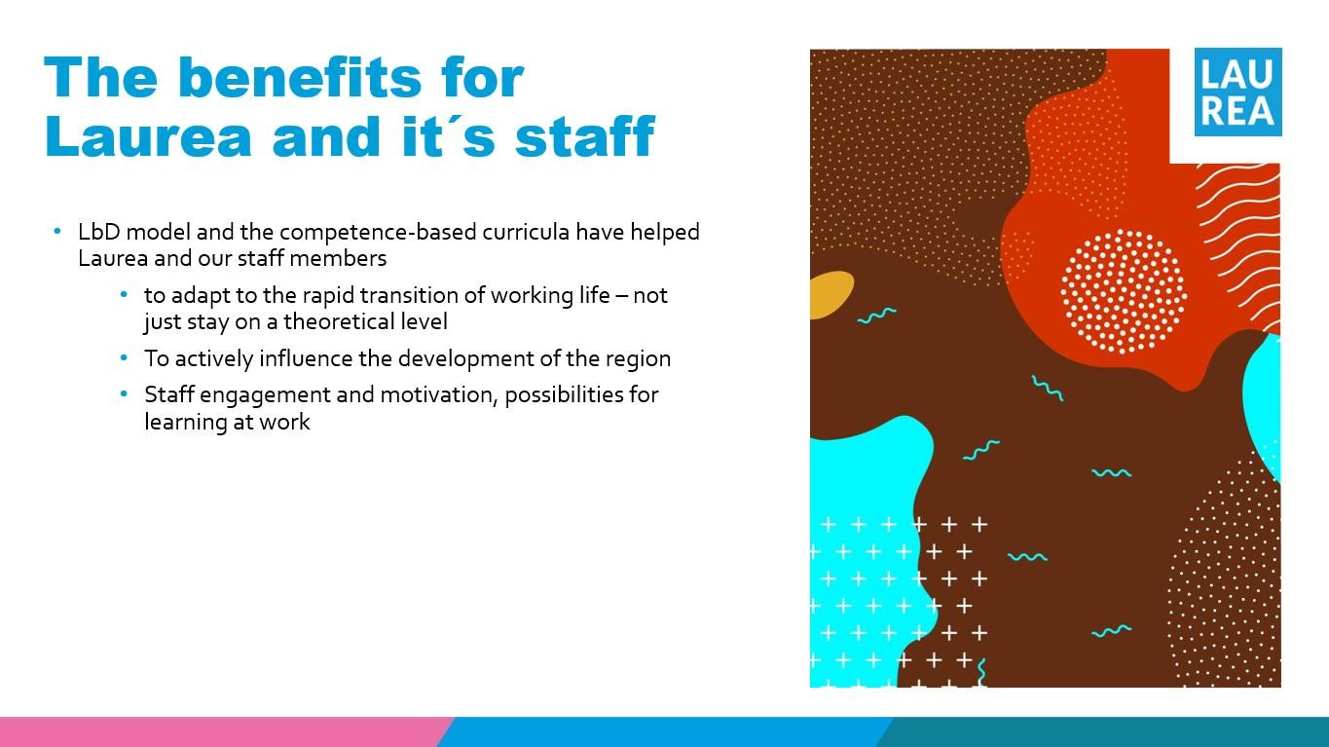

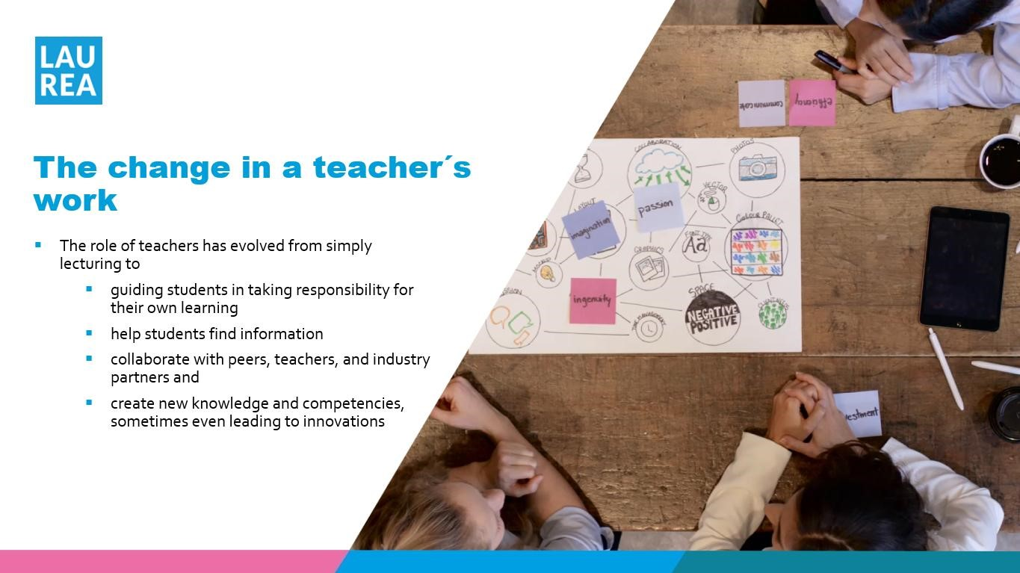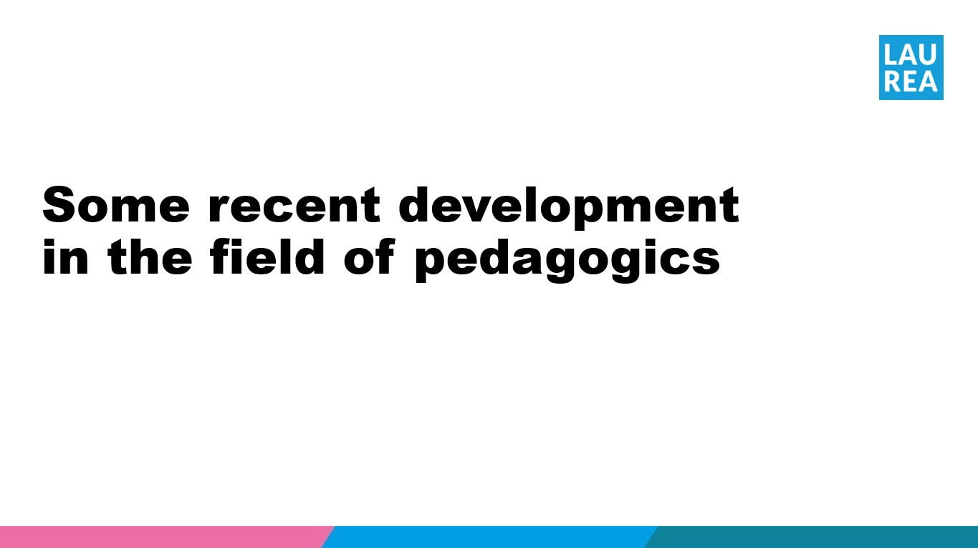

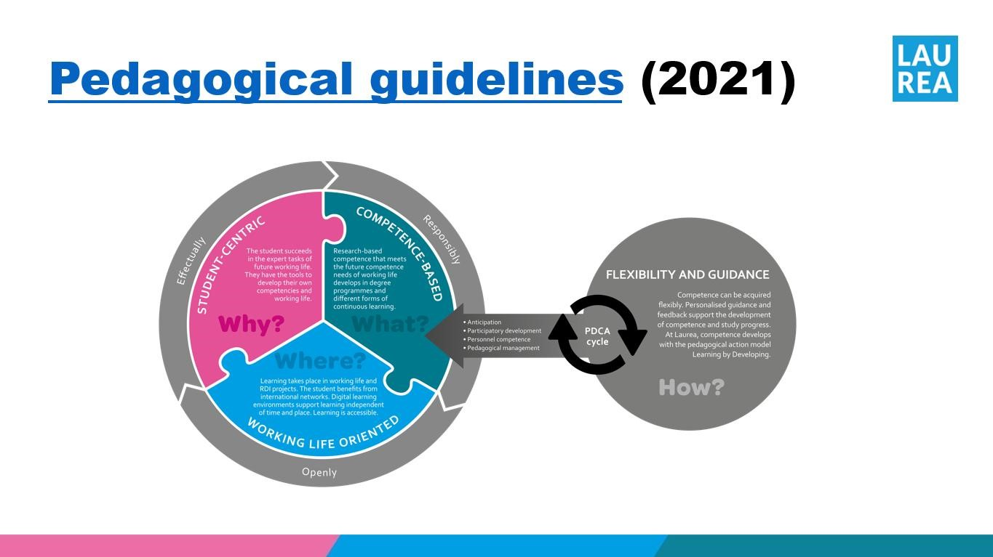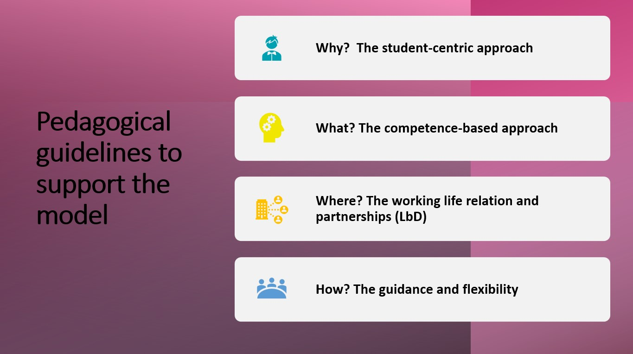

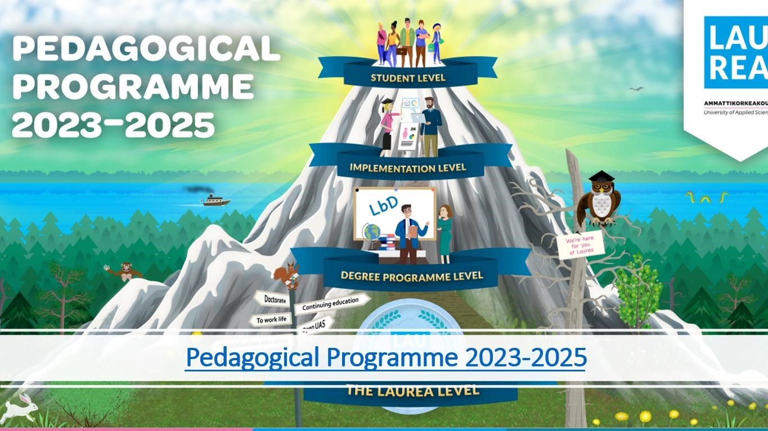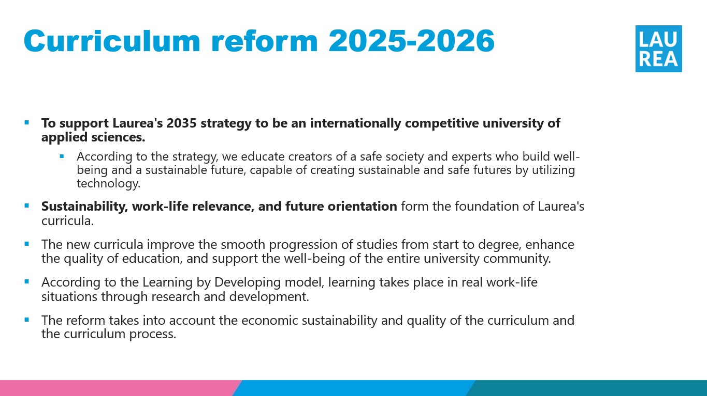

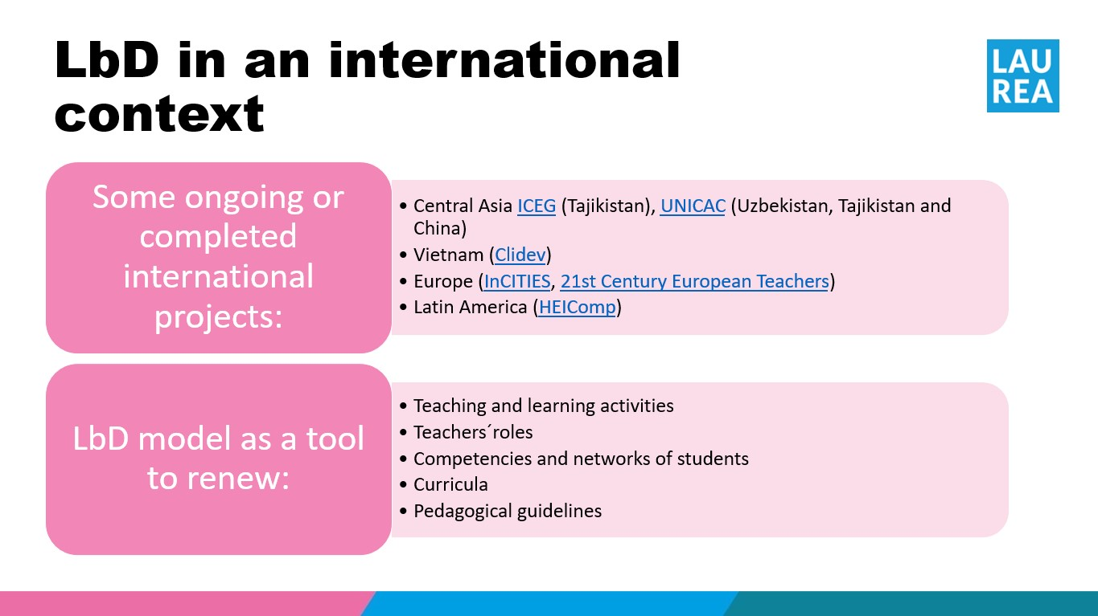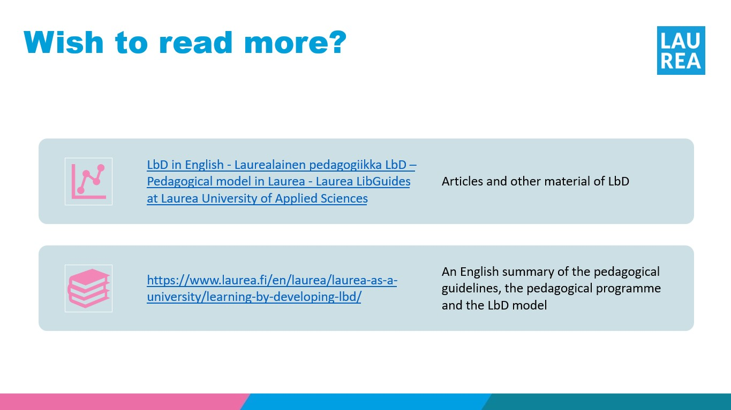

Rittel and Webber (1973) coined the term "wicked problems" to describe challenges that require systemic transformations, noting that they lack clear solutions and involve conflicting objectives.

